4.2 Handling duplicates, missing values, nulls

Dataflow Gen2
- Duplicates can be removed quite simply by right-clicking on a column (or selecting multiple columns, and then right-clicking), then selecting Remove Duplicates

- Missing values can be handled either by:

- Filtering out that row of data, if there is a missing or NULL value.

- Replace Values - you can 'replace' the NULL value with a specific value. Or...

- Fill Up/ Down - Fill Down fills empty cells with the value in the cell directly above the empty cell, starting from the top. Fill Up does the opposite.

T-SQL Data Warehouse
There are a number of methods for removing duplicate data using T-SQL.
- Using SELECT DISTINCT col_name FROM table is the simplest way.
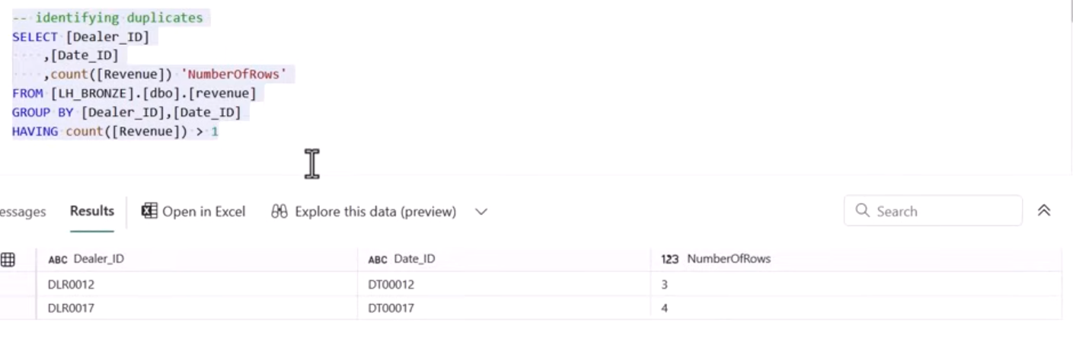
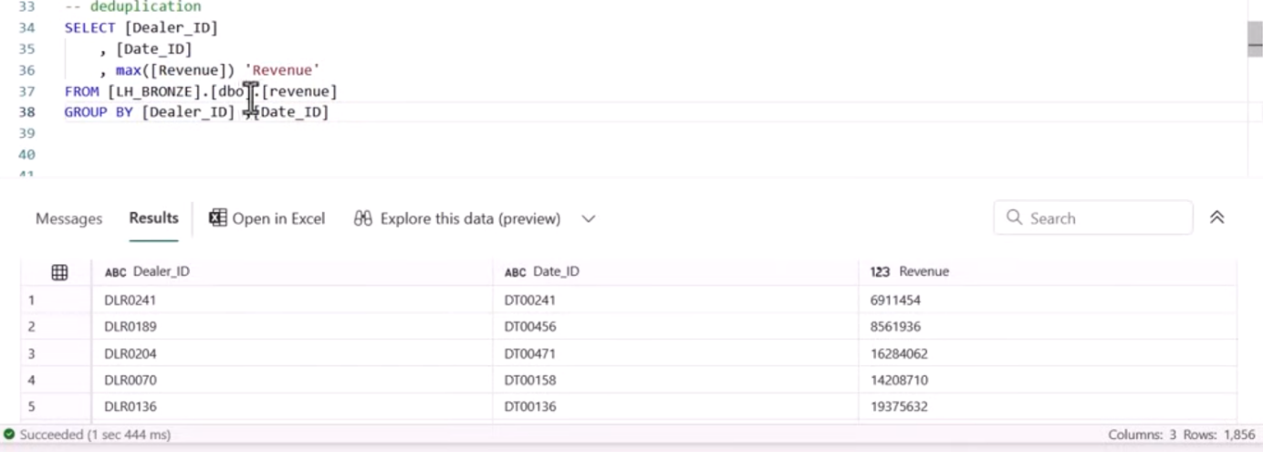
You can update your data in a Data Warehouse table to handle/ replace NULL values, like so:
UPDATE table_name
SET column_name = 'Something Else'
WHERE column_name IS NULL
Another method would be to remove these rows from your dataset entirely:
SELECT * from my_table
WHERE important_column IS NOT NULL

